Zone Parking
On-street parking places in central Belgrade are in time-restricted zones, while parking in areas with lower demand is not time-restricted.
Parking charges in zones apply Monday to Friday, 07.00 till 21.00; Saturday 07.00. till 14.00. Parking on Sunday is free. On-street parking in zones with time restrictions is divided into four hourly zones, limited to a maximum stay (half an hour, one hour, two hours and three hours):
Zone A - 30 minutes
Red zone (1st) - 60 minutes , extended parking time 30 minutes
Yellow zone (2nd) – 120 minutes, extended parking time 60 minutes
Green zone (3rd) – 180 minutes, extended parking time 60 minutes.
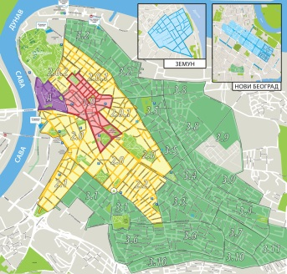Extended parking time can be paid within 5 minutes before the time limit of the zone expires, in accordance with the special parking tariff system. After the parking time expires, the vehicle cannot be parked in the same zone in the next 30 minutes.
After 5 PM, Monday to Friday, there is no charge for using approximately 400 places in the third zone (green zone) around the Clinical centre of Serbia.
There are specially marked “Pupils Parking Spaces” nearby 32 elementary schools within zoned area, custom designed to signalise that collected parking payment from these spaces is transferred to the schools for the teaching aids and tools. Also, in front of four maternity hospitals (GAK Narodni Front, KCS – The Obstetrics and Gynaecology Clinic, KBC Zvezdara and KBC Zemun), total of twenty-four “Baby Parking Spaces” were marked and the collected parking payment from these places is used for the purchase of medical equipment.
A zone without a time limit (so called blue zone) enables parking to be paid for as long as needed. Parking charges Monday to Friday from 08.00 to 21.00 (some parking lots from 08.00 to17.00), Saturday from 08.00 to 14.00, according to vertical traffic signs.
Homework assignment
1.Translate one passage from the text and make your list of technical terms
2.Explain the system of zone parking in your own words
3. Write a paragraph about your personal experience in using parking services

